Sr. NO. | Title | Page No.
1. | Acknowledgment | 4
2. | Preface | 5
3. | Definition | 6
4. | Problem Statement | 8
5. | Objective | 9
6. | Hardware and Software Used | 11
7. | Source Code | 13
8. | Output | 27
9. | Contribution to Real World | 31
10. | Bibliography | 33
11. | Thank You | 34
Index

Acknowledgment

Iundertook this Project work, as the part of my XII-Computer Science course. I had tried to apply my best of knowledge and experience, gained during the study and class work experience. However, developing software system is generally a quite complex and time-consuming process. It requires a systematic study, insight vision and professional approach during the design and development. Moreover, the developer always feels the need, the help and good wishes of the people near you, who have considerable experience and idea.
I would like to extend my sincere thanks and gratitude to my teacher Ms. Ritu Dembla . I am very much thankful to our Principal Dr. Smita Laur for giving valuable time and moral support to develop this software.
I also feel indebted to my friends for their valuable suggestions during the project work.

Preface

This project aims to develop a comprehensive Bank Management System that streamlines banking operations, ensuring efficient account management, enhanced security, and improved customer service. With the increasing complexity of financial transactions and the growing need for automation, this system addresses the challenges of manual processes, making banking operations faster, more accurate, and secure.
The Bank Management System is designed to manage customer accounts, track balances, perform transactions, and provide employees with real-time access to critical information. It incorporates features such as employee login authentication, account creation, balance checking, and transaction processing. These features not only improve internal workflows but also enhance the overall customer experience by providing immediate access to account information.
In an era where digital banking is becoming increasingly important, the system ensures the security and integrity of sensitive data while supporting scalability for future growth. By automating routine tasks and improving access to real-time data, this system provides a foundation for efficient banking operations, contributing to the bank's overall success and customer satisfaction.
This program is a significant step towards modernizing banking systems, offering a robust solution to the challenges faced by financial institutions today.

Definition

A Bank Management System is a software application that helps manage the various banking operations such as account creation, balance checking, deposits, withdrawals, and transfers between accounts. It can be developed using Python, SQL, and Tkinter for the graphical user interface (GUI).

Features of a Bank Management System:
A typical Bank Management System includes several essential features, such as:
- Account Creation: Allows the bank to register new customers by storing personal details and initial deposit information.
- Login/Authentication: Provides a secure login system to ensure that only authorized users (e.g., bank staff or customers) can access the system.
- Deposit and Withdrawal: Customers can deposit funds into their account or withdraw money, with checks in place to prevent overdrawing.
- Account Overview: Displays the current balance, personal details, and transaction history of an account holder.
- Transaction History: Logs and displays the history of deposits, withdrawals, and transfers for each user.
- Funds Transfer: Customers can transfer money between accounts within the same bank.
- Simple Reports: Basic reports showing the total balance and transaction history of customers.

Architecture and Design:
The system can be divided into three primary layers:
- Database Layer (SQL): The database layer manages data storage and ensures that user information and transactions are securely saved. We can use SQLite to store customer data, transaction records, and balance information.
- Business Logic Layer (Python): This layer contains the core functionality of the Bank Management System, such as performing transactions, handling account balance updates, and logging activities.
- Presentation Layer (Tkinter): The user interface (UI) is the front end that allows users (bank employees or customers) to interact with the system. Tkinter is used to create forms, buttons, labels, and other interactive elements.

Database Design:
To store customer data, we can design two primary tables in SQL:
- Customers Table: Stores basic information about customers, including their ID, name, address, and balance.
- Transactions Table: Logs every transaction made, such as deposits, withdrawals, and transfers. It stores the transaction type, amount, date, and the customer ID associated with the transaction.

Tkinter User Interface:
The Tkinter library is used to build the graphical user interface (GUI) for the Bank Management System. The interface consists of windows for login, account management, and transaction processing. The GUI can be extended to include other functionalities such as balance checking, deposit/withdrawal forms, and transaction history displays.

Problem Statement

In traditional banking systems, manual processes for managing customer accounts, processing transactions, and maintaining customer data are time-consuming, prone to errors, and lack scalability. These inefficiencies lead to delays in customer service, increased human errors, and difficulties in handling large volumes of data, especially as the bank grows. Furthermore, the lack of secure and automated systems for accessing sensitive information creates vulnerabilities in data security, exposing both the bank and its customers to potential risks.
The challenge lies in developing an automated, secure, and scalable system that can streamline banking operations, enhance data security, and improve the efficiency of both employees and customers.
A solution is needed that can:
- Automate account creation, modification, and deletion.
- Provide real-time access to account balances and transaction histories.
- Ensure secure access to sensitive customer data through employee login authentication.
- Handle an increasing volume of transactions and customer data as the bank expands.

This project aims to address these challenges by creating a Bank Management System that automates routine tasks, improves operational efficiency, ensures data security, and supports the bank’s growth, all while delivering a seamless and transparent experience to customers.

Objective

The Bank Management System project using Python, SQL, and Tkinter provides a robust platform for developing essential skills in software development and problem-solving. This project bridges the gap between theoretical learning and practical application, giving students the opportunity to work on a real-world simulation of a banking system. By tackling challenges in GUI design, database management, and secure data handling, students will gain a well-rounded understanding of programming principles, enhancing their preparation for more complex software development tasks.

Key Objectives and Scope:

- Graphical User Interface (GUI):
  - Designing an intuitive, interactive, and user-friendly interface using Tkinter.
  - The GUI facilitates seamless interactions for both customers and employees, providing a visually appealing and organized layout.
  - Ensuring the interface is responsive and professional, enhancing user experience and accessibility.
- Database Integration:
  - Leveraging SQL (SQLite/MySQL) to manage banking records securely.
  - Storing critical data such as customer information, account details, transaction logs, and employee credentials.
  - Ensuring data integrity and efficient retrieval through optimized queries and well-structured database schemas.
- Core Banking Operations:
  - Implementing fundamental banking functions, including:
    - Account creation and management.
    - Processing deposits, withdrawals, and fund transfers.
    - Checking account balances and generating transaction histories.
  - Ensuring proper validation, error handling, and accurate updates to the database for all operations.
- Security and Authentication:
  - Introducing an employee login system to restrict unauthorized access and ensure secure operation.
  - Implementing encrypted storage for passwords and sensitive information.
  - Providing role-based access, differentiating between customer and employee functionalities.
- Learning Outcomes:
  - Hands-on experience with GUI development using Tkinter.
  - Practical knowledge of integrating SQL databases with Python applications.
  - Understanding of software design principles, including modularity, maintainability, and scalability.
  - Insights into implementing real-world applications of authentication and security measures.

This project not only focuses on the technical aspects but also emphasizes critical thinking, problem-solving, and collaboration, providing a holistic approach to understanding and implementing software systems.

Hardware and Software Used

Hardware:
- Computer/Server:
  - A computer or server is required to run the banking system application, host the database, and manage user requests. It should have sufficient processing power, memory (RAM), and storage to support the software, handle concurrent user requests, and ensure smooth operation of the system.
- Input Devices:
  - Keyboard and Mouse: For inputting data such as customer information, transaction details, and performing administrative tasks within the system.
- Printer (Optional):
  - A printer can be used to generate receipts or transaction reports for customers, especially for printed statements or account summaries.
- Network Connectivity:
  - Reliable internet or intranet connection to ensure real-time synchronization between different components of the system and facilitate remote access or updates.

Software:
- Operating System:
  - Windows/Linux: The banking management system can run on either Windows or Linux-based operating systems, providing a stable environment for hosting the software.
- Database Management System (DBMS):
  - MySQL: MySQL is used for managing the bank's database, storing customer data, transaction histories, account details, and other necessary records in an organized manner.
- Programming Language:
  - Python: Python is used to build the bank management system application due to its simplicity, readability, and extensive libraries, allowing easy integration with the MySQL database for seamless data operations.
- GUI Development:
  - Tkinter: Tkinter, a Python library, is used for developing the graphical user interface (GUI) of the system, allowing users to interact with the banking system in an intuitive manner.
- Database Management Tools:
  - MySQL Workbench: Used for designing, querying, and managing the database, including setting up tables, relationships, and executing queries for customer and transaction data management.
- Security Tools:
  - SSL/TLS Encryption (Optional): Secure Sockets Layer (SSL) or Transport Layer Security (TLS) can be used to encrypt sensitive data during transmission, ensuring data security during online transactions and remote access.

These hardware and software components work together to create a seamless, efficient, and secure banking management system, automating core tasks and providing real-time access to customer and transaction information

Source Code
SQL:
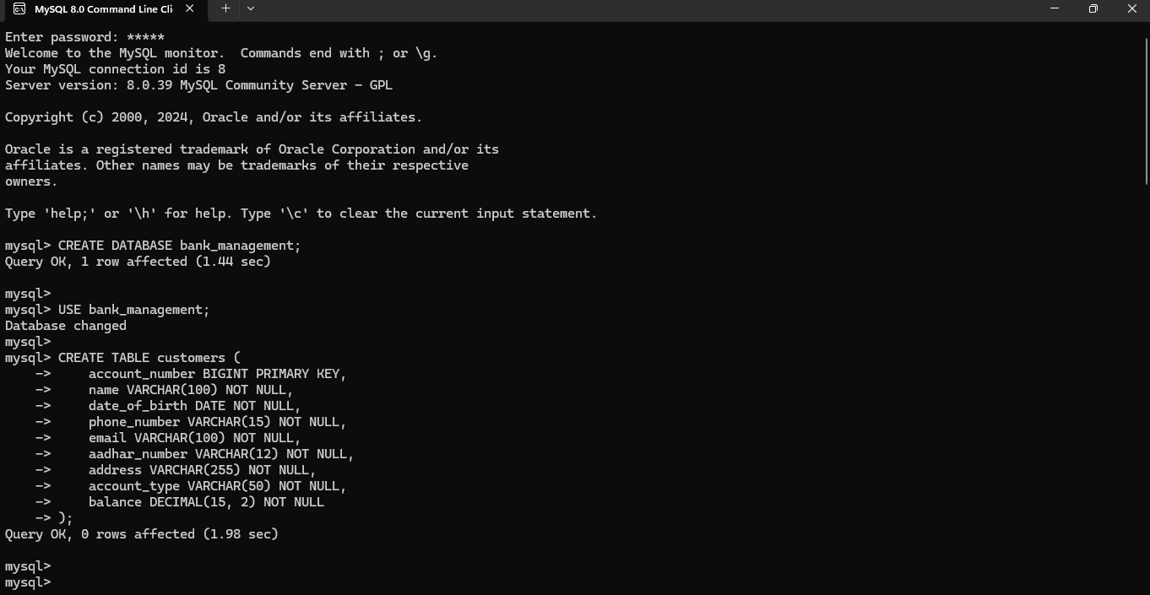
- Creating Database “bank_management” and Table “customers”

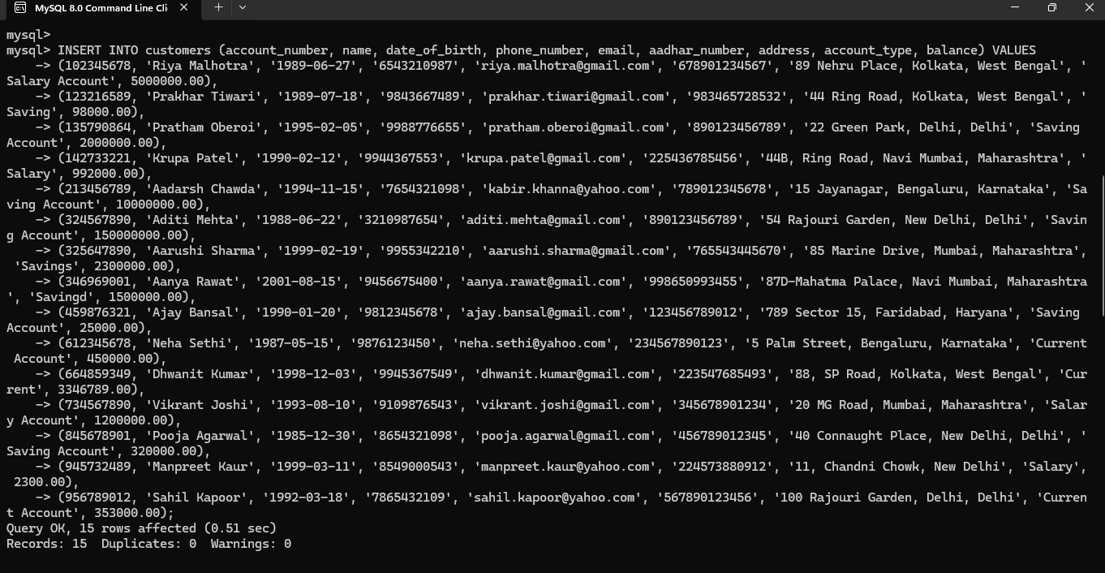
- Inserting values into table “customers”

Python:

import tkinter as tk
from tkinter import messagebox
import mysql.connector
from PIL import Image, ImageTk
import bcrypt

# Employee credentials
employee_id = {
"username": "emp_007",
"password": bcrypt.hashpw(b"007", bcrypt.gensalt())
}

# Database Connection
def create_connection():
"""Establish a connection to the MySQL database."""
try:
connection = mysql.connector.connect(
host='localhost',
user='root',
password='12345',
database='bank_management'
)
return connection
except mysql.connector.Error as e:
messagebox.showerror("Database Error", f"Connection failed: {e}")
return None

# Employee Login
def employee_login(username, password):
"""Handle employee login."""
if username == employee_id["username"] and bcrypt.checkpw(password.encode('utf-8'), employee_id["password"]):
messagebox.showinfo("Login Successful", f"Welcome to DT Bank, {username}!")
return True
else:
messagebox.showerror("Login Failed", "Incorrect username or password. Please try again.")
return Fals

# Customer Account Management Functions

#1.Create Customer
def create_customer(account_number, name, dob, phone, email, aadhar_number, address, account_type, initial_balance):
"""Create a new customer account in the database."""
try:
initial_balance = float(initial_balance)
if initial_balance < 0:
raise ValueError("Initial balance must be a non-negative number.")

except ValueError as e:
messagebox.showerror("Input Error", str(e))
return

connection = create_connection()
if connection is None:
return

cursor = connection.cursor()
try:
query = """
INSERT INTO customers (account_number, name, date_of_birth, phone_number, email, aadhar_number, address, account_type, balance)
VALUES (%s, %s, %s, %s, %s, %s, %s, %s, %s)
"""
cursor.execute(query, (account_number, name, dob, phone, email, aadhar_number, address, account_type, initial_balance))
connection.commit()
messagebox.showinfo("Success", "Customer created successfully!")
except mysql.connector.Error as err:
messagebox.showerror("Error", f"Error: {err}")
finally:
cursor.close()
connection.close()

#View Customer
def view_customer(account_number):
"""View customer details based on account number."""
connection = create_connection()
if connection is None:
return

cursor = connection.cursor()
query = "SELECT * FROM customers WHERE account_number = %s"

try:
cursor.execute(query, (account_number,))
customer = cursor.fetchone()

if customer:
details = (f"Account Number: {customer[0]}\n"
f"Name: {customer[1]}\n"
f"DOB: {customer[2]}\n"
f"Phone: {customer[3]}\n"
f"Email: {customer[4]}\n"
f"Aadhar: {customer[5]}\n"
f"Address: {customer[6]}\n"
f"Account Type: {customer[7]}\n"
f"Balance: ₹{customer[8]:,.2f}")
messagebox.showinfo("Customer Details", details)
else:
messagebox.showerror("Error", "Customer not found.")
except mysql.connector.Error as err:
messagebox.showerror("Database Error", f"Error: {err}")
finally:
cursor.close()
connection.close()

#Update Customer
def update_customer(account_number, field, new_value):
"""Update customer information in the database."""
connection = create_connection()
if connection is None:
return

cursor = connection.cursor()

if field not in ['name', 'phone_number', 'email', 'aadhar_number', 'address', 'account_type']:
messagebox.showerror("Error", "Invalid field for update.")
cursor.close()
connection.close()
return

messagebox.showerror("Input Error", "Invalid email format.")
cursor.close()
connection.close()
return

query = f"UPDATE customers SET {field} = %s WHERE account_number = %s"
cursor.execute(query, (new_value, account_number))
connection.commit()

if cursor.rowcount > 0:
messagebox.showinfo("Success", f"Updated {field} successfully!")
else:
messagebox.showerror("Error", "Failed to update customer details.")

cursor.close()
connection.close()

#Delete Customer
def delete_customer(account_number):
"""Delete a customer from the database."""
connection = create_connection()
if connection is None:
return

cursor = connection.cursor()
query = "DELETE FROM customers WHERE account_number = %s"
cursor.execute(query, (account_number,))
connection.commit()

if cursor.rowcount > 0:
messagebox.showinfo("Success", "Customer deleted successfully!")
else:
messagebox.showerror("Error", "Customer not found.")

cursor.close()
connection.close()

#Perform Transactions
def perform_transaction(account_number, amount, transaction_type):
"""Perform a deposit or withdrawal transaction."""
connection = create_connection()
if connection is None:
return

cursor = connection.cursor()

try:
amount = float(amount)
if amount <= 0:
messagebox.showerror("Input Error", "Amount must be a positive number.")
return

if transaction_type == 'Deposit':
update_query = "UPDATE customers SET balance = balance + %s WHERE account_number = %s"
cursor.execute(update_query, (amount, account_number))
elif transaction_type == 'Withdrawal':
cursor.execute("SELECT balance FROM customers WHERE account_number = %s", (account_number,))
balance = cursor.fetchone()
if balance is None:
messagebox.showerror("Error", "Account not found.")
return
if balance[0] < amount:
messagebox.showerror("Error", "Insufficient funds.")
return
update_query = "UPDATE customers SET balance = balance - %s WHERE account_number = %s"
cursor.execute(update_query, (amount, account_number))
else:
messagebox.showerror("Error", "Invalid transaction type.")
return

connection.commit()
messagebox.showinfo("Success", f"{transaction_type} of ₹{amount:,.2f} completed successfully!")
except ValueError:
messagebox.showerror("Input Error", "Please enter a valid number for the amount.")
except mysql.connector.Error as err:
messagebox.showerror("Error", f"Transaction failed: {err}")
finally:
cursor.close()
connection.close()

#Check Balance
def check_balance(account_number):
"""Check the balance of a customer account."""
connection = create_connection()
if connection is None:
return

cursor = connection.cursor()
query = "SELECT name, balance FROM customers WHERE account_number = %s"
cursor.execute(query, (account_number,))
result = cursor.fetchone()

if result:
name, balance = result
messagebox.showinfo("Balance Inquiry", f"Account Holder: {name}\nCurrent Balance: ₹{balance:,.2f}")
else:
messagebox.showerror("Error", "Account not found.")

cursor.close()
connection.close()

# GUI Functions

#1.Window for Create Customer Account

def create_customer_account():
create_window = tk.Toplevel()
create_window.title("Create Customer Account")
create_window.geometry("500x700")
create_window.configure(bg="#E0F2F1")

tk.Label(create_window, text="Create Customer Account", font=("Arial", 18, "bold"), bg="#E0F2F1").pack(pady=10)

labels = [
"Account Number:", "Name:", "Date of Birth (YYYY-MM-DD):",
"Phone Number:", "Email:", "Aadhar Number:",
"Address:", "Account Type:", "Initial Balance:"
]
entries = []

for label in labels:
tk.Label(create_window, text=label, bg="#E0F2F1").pack(pady=5)
entry = tk.Entry(create_window)
entry.pack(pady=5, padx=20, fill=tk.X)
entries.append(entry)

tk.Button(create_window, text="Submit", bg="#87CEFA", command=lambda: create_customer(
entries[0].get(), entries[1].get(), entries[2].get(),
entries[3].get(), entries[4].get(), entries[5].get(),
entries[6].get(), entries[7].get(), entries[8].get()
)).pack(pady=20)

#2.Window for View Customer Account
def view_customer_details():
view_window = tk.Toplevel()
view_window.title("View Customer Details")
view_window.geometry("500x300")
view_window.configure(bg="#E0F2F1")

tk.Label(view_window, text="View Customer Details", font=("Arial", 18, "bold"), bg="#E0F2F1").pack(pady=10)

tk.Label(view_window, text="Account Number:", bg="#E0F2F1").pack(pady=5)
acc_num_entry = tk.Entry(view_window)
acc_num_entry.pack(pady=5, padx=20, fill=tk.X)

tk.Button(view_window, text="View Details", bg="#87CEFA", command=lambda: view_customer(acc_num_entry.get())).pack(pady=10)

#3.Window for Displaying Customer Details
def update_customer_details():
update_window = tk.Toplevel()
update_window.title("Update Customer Details")
update_window.geometry("500x300")
update_window.configure(bg="#E0F2F1")

tk.Label(update_window, text="Update Customer Details", font=("Arial", 18, "bold"), bg="#E0F2F1").pack(pady=10)

tk.Label(update_window, text="Account Number:", bg="#E0F2F1").pack(pady=5)
acc_num_entry = tk.Entry(update_window)
acc_num_entry.pack(pady=5, padx=20, fill=tk.X)

tk.Label(update_window, text="Field to Change (e.g., name, phone_number):", bg="#E0F2F1").pack(pady=5)
field_entry = tk.Entry(update_window)
field_entry.pack(pady=5, padx=20, fill=tk.X)

tk.Label(update_window, text="New Value:", bg="#E0F2F1").pack(pady=5)
new_value_entry = tk.Entry(update_window)
new_value_entry.pack(pady=5, padx=20, fill=tk.X)

tk.Button(update_window, text="Update", bg="#87CEFA", command=lambda: update_customer(acc_num_entry.get(), field_entry.get(), new_value_entry.get())).pack(pady=20)

#4.Window for Transaction
def perform_transaction_window():
transaction_window = tk.Toplevel()
transaction_window.title("Perform Transaction")
transaction_window.geometry("500x400")
transaction_window.configure(bg="#E0F2F1")

tk.Label(transaction_window, text="Perform Transaction", font=("Arial", 18, "bold"), bg="#E0F2F1").pack(pady=10)

tk.Label(transaction_window, text="Account Number:", bg="#E0F2F1").pack(pady=5)
acc_num_entry = tk.Entry(transaction_window)
acc_num_entry.pack(pady=5, padx=20, fill=tk.X)

tk.Label(transaction_window, text="Amount:", bg="#E0F2F1").pack(pady=5)
amount_entry = tk.Entry(transaction_window)
amount_entry.pack(pady=5, padx=20, fill=tk.X)

tk.Label(transaction_window, text="Transaction Type:", bg="#E0F2F1").pack(pady=5)
transaction_type_var = tk.StringVar(value='Deposit')
tk.Radiobutton(transaction_window, text="Deposit", variable=transaction_type_var, value='Deposit', bg="#E0F2F1").pack(pady=5)
tk.Radiobutton(transaction_window, text="Withdrawal", variable=transaction_type_var, value='Withdrawal', bg="#E0F2F1").pack(pady=5)

tk.Button(transaction_window, text="Submit", bg="#87CEFA", command=lambda: perform_transaction(acc_num_entry.get(), amount_entry.get(), transaction_type_var.get())).pack(pady=20)

#5.Window for Viewing Balance of Customer
def check_balance_window():
balance_window = tk.Toplevel()
balance_window.title("Check Balance")
balance_window.geometry("500x300")
balance_window.configure(bg="#E0F2F1")

tk.Label(balance_window, text="Check Balance", font=("Arial", 18, "bold"), bg="#E0F2F1").pack(pady=10)

tk.Label(balance_window, text="Account Number:", bg="#E0F2F1").pack(pady=5)
acc_num_entry = tk.Entry(balance_window)
acc_num_entry.pack(pady=5, padx=20, fill=tk.X)

tk.Button(balance_window, text="Check Balance", bg="#87CEFA", command=lambda: check_balance(acc_num_entry.get())).pack(pady=20)

#6.Window for Deleting Account
def delete_customer_account():
delete_window = tk.Toplevel()
delete_window.title("Delete Customer Account")
delete_window.geometry("500x300")
delete_window.configure(bg="#E0F2F1")

tk.Label(delete_window, text="Delete Customer Account", font=("Arial", 18, "bold"), bg="#E0F2F1").pack(pady=10)

tk.Label(delete_window, text="Account Number:", bg="#E0F2F1").pack(pady=5)
acc_num_entry = tk.Entry(delete_window)
acc_num_entry.pack(pady=5, padx=20, fill=tk.X)

tk.Button(delete_window, text="Delete Account", bg="#87CEFA", command=lambda: delete_customer(acc_num_entry.get())).pack(pady=20)

#Showing Menu
def show_menu():
menu_window = tk.Tk()
menu_window.title("Menu - Bank Management System")
menu_window.geometry("850x650")
menu_window.configure(bg="#FFFFFF")

logo_path = r"D:\Pratham\python programs\12 proj\logo.png"

try:
logo = Image.open(logo_path)
logo = logo.resize((200, 100), Image.Resampling.LANCZOS)
logo = ImageTk.PhotoImage(logo)

header_frame = tk.Frame(menu_window, bg="#00796B", padx=10, pady=10)
header_frame.pack(fill=tk.X)

logo_label = tk.Label(header_frame, image=logo, bg="#00796B")
logo_label.pack(pady=20)

except Exception as e:
print(f"Error loading logo: {e}")
logo = None

menu_frame = tk.Frame(menu_window, bg="#E0F2F1", padx=10, pady=10)
menu_frame.pack(expand=True, fill=tk.BOTH)

tk.Label(menu_frame, text="Select an option to proceed:", font=("Arial", 18, "bold"), bg="#E0F2F1").pack(pady=10)

functions = {
"Create New Account": create_customer_account,
"View Account Details": view_customer_details,
"Update Account Details": update_customer_details,
"Perform Transaction": perform_transaction_window,
"Check Account Balance": check_balance_window,
"Delete Account": delete_customer_account,
"Exit": menu_window.destroy
}

for func_name, func_command in functions.items():
btn_color = "#B2DFDB" if func_name == "Create New Account" else (
"#C8E6C9" if func_name == "View Account Details" else (
"#FFE082" if func_name == "Update Account Details" else (
"#80DEEA" if func_name == "Perform Transaction" else (
"#FFCCBC" if func_name == "Check Account Balance" else (
"#F44336" if func_name == "Delete Account" else "#FFAB91")))))
btn = tk.Button(menu_frame, text=func_name, font=("Arial", 14), bg=btn_color, fg="black", command=func_command)
btn.pack(pady=5, padx=20, fill=tk.X)

menu_window.mainloop()

#For Login Button
def handle_login(username_entry, password_entry, login_window):
"""Handle the login process."""
username = username_entry.get()
password = password_entry.get()

if employee_login(username, password):
login_window.destroy()
show_menu()

# Define the login window function
def create_login_window():
"""Display the login screen for the bank management system."""
login_window = tk.Tk()
login_window.title("Employee Login - DT Bank")

window_width = 800
window_height = 600
login_window.geometry(f"{window_width}x{window_height}")
login_window.configure(bg="#FFFFFF")

logo_path = r"D:\Pratham\python programs\12 proj\logo.png"

try:
logo = Image.open(logo_path)
logo = logo.resize((200, 100), Image.Resampling.LANCZOS) # Resize the logo as needed
logo = ImageTk.PhotoImage(logo)

header_frame = tk.Frame(login_window, bg="#00796B", padx=10, pady=10)
header_frame.pack(fill=tk.X)

logo_label = tk.Label(header_frame, image=logo, bg="#00796B")
logo_label.pack(pady=10)

except Exception as e:
print(f"Error loading logo: {e}")
logo = None

login_frame = tk.Frame(login_window, bg="#E0F2F1", padx=10, pady=10)
login_frame.pack(expand=True, fill=tk.BOTH)

tk.Label(login_frame, text="Employee Login", font=("Arial", 18, "bold"), bg="#E0F2F1").pack(pady=20)

tk.Label(login_frame, text="Username:", font=("Arial", 12), bg="#E0F2F1").pack(pady=5)
username_entry = tk.Entry(login_frame, font=("Arial", 12))
username_entry.pack(pady=5)

tk.Label(login_frame, text="Password:", font=("Arial", 12), bg="#E0F2F1").pack(pady=5)
password_entry = tk.Entry(login_frame, font=("Arial", 12), show="*")
password_entry.pack(pady=5)

login_button = tk.Button(login_frame, text="Login", font=("Arial", 12, "bold"), bg="#00796B", fg="white", width=20, command=lambda: handle_login(username_entry, password_entry, login_window))
login_button.pack(pady=20)

login_window.mainloop()

if __name__ == "__main__":
create_login_window()

Output
- MySQL Tables
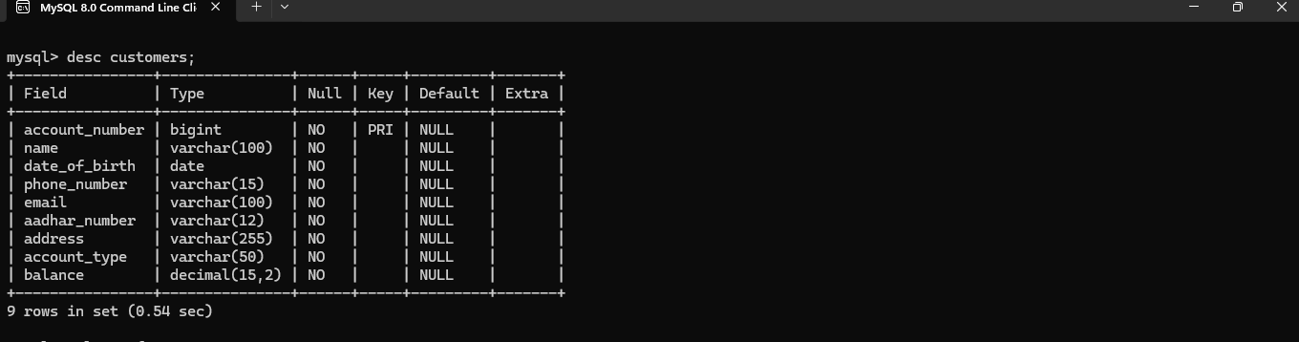
- ^{Describing Table “customers”:}

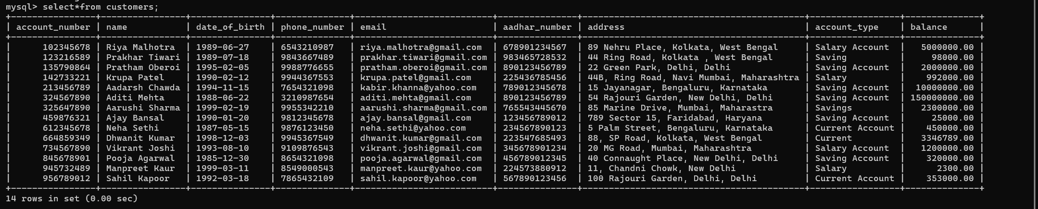
- ^{Table “customers”:}

- Performing Code
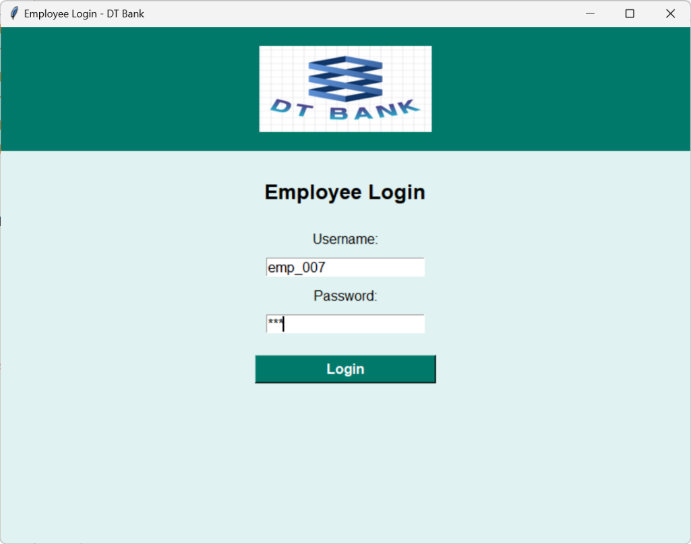
- Login

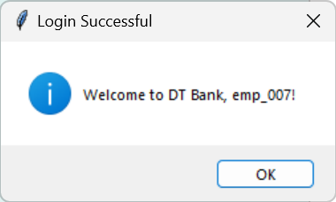

- Menu
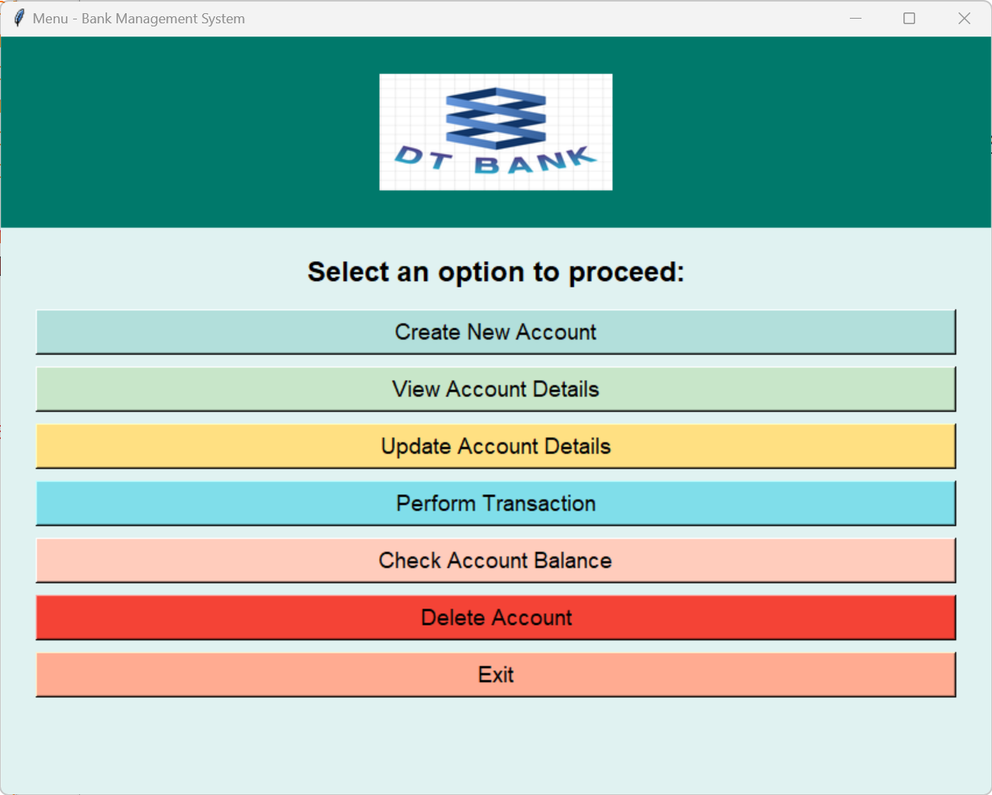

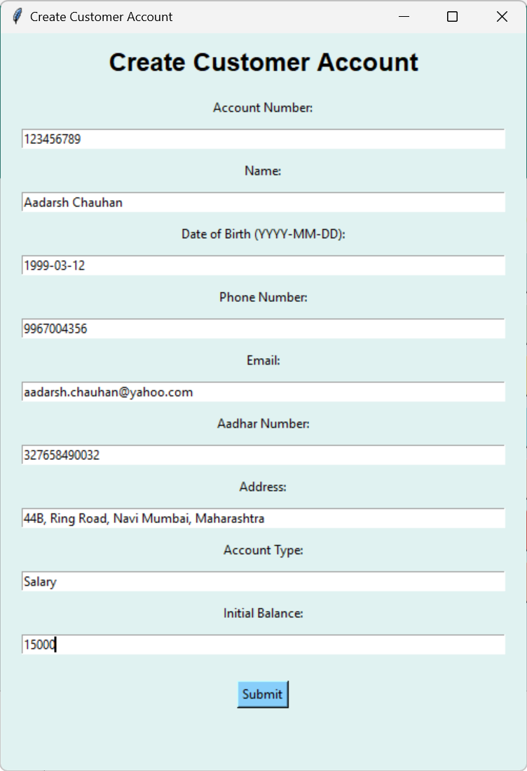
- Create New Account

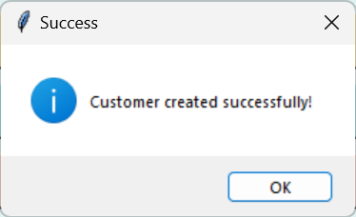

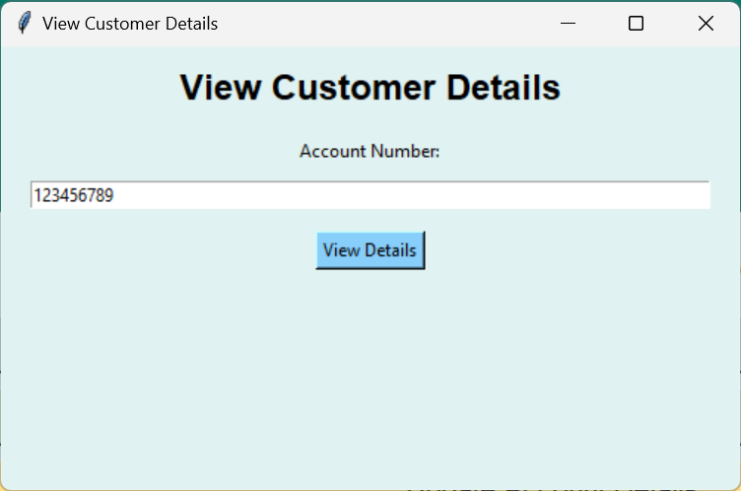
- View Customer Details

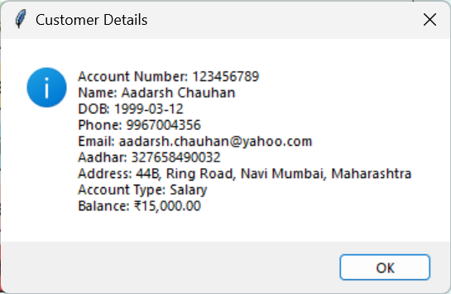

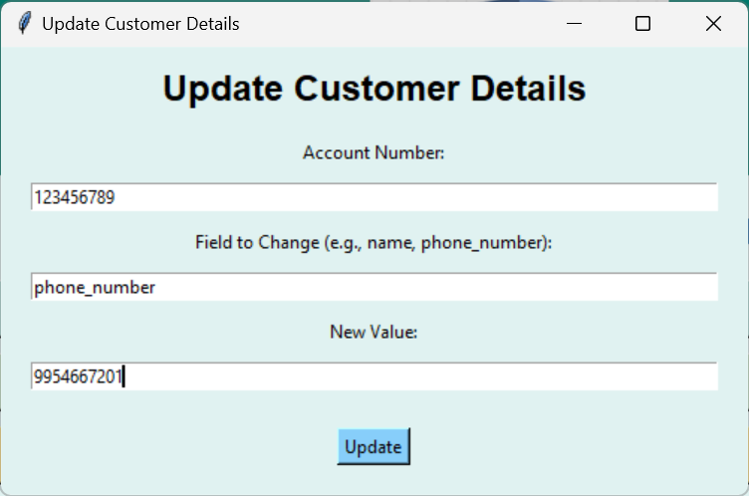
5. Update Customer Details

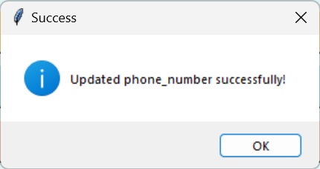

6. Perform Transaction
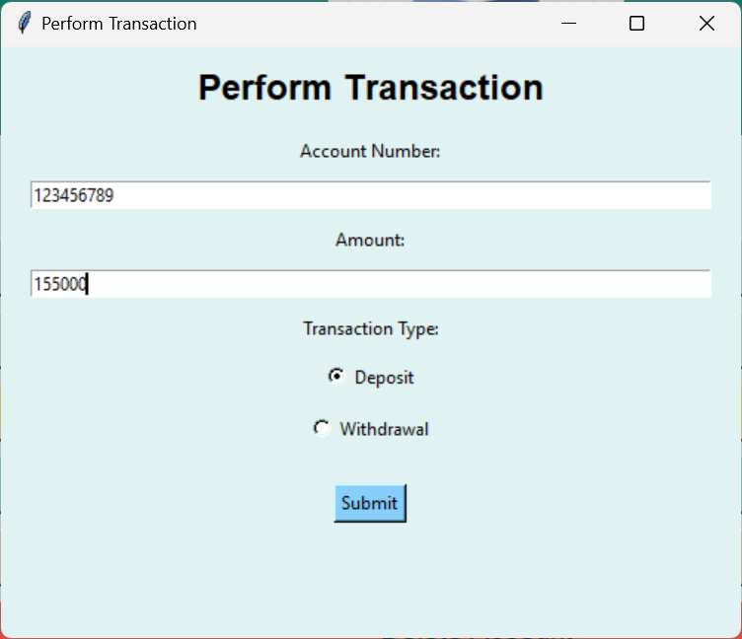

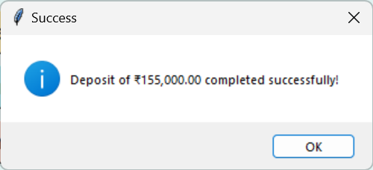

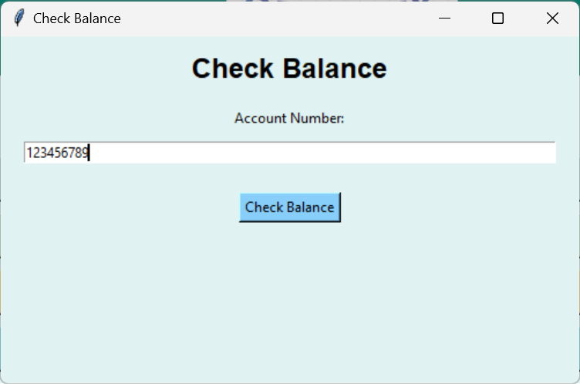
- Check Balance

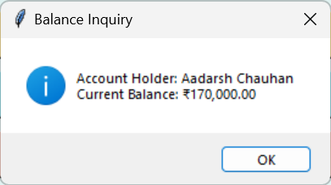

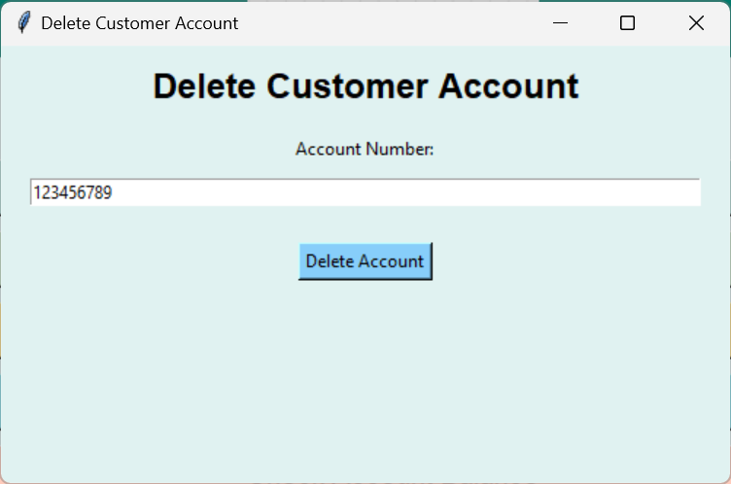
- Delete Account

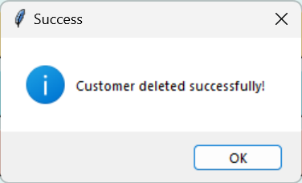

Contribution to Real World

The Bank Management System designed for this project offers several valuable contributions to the real world, particularly in terms of efficiency, security, and customer service within the banking sector. Below are some key aspects of how this project contributes to the real-world banking environment:
- Improved Operational Efficiency: Automating account management tasks like adding, modifying, or deleting customer accounts reduces manual labor, speeds up operations, and minimizes human errors. This allows employees to focus on more important tasks, such as customer interaction, instead of administrative work.
- Enhanced Security: The employee login feature with proper authentication ensures only authorized individuals can access sensitive data and perform key functions. This enhances security, protecting both the bank’s and customers' data from unauthorized access and cyber threats, which is crucial in today’s digital environment.
- Real-time Data Access: The system provides real-time access to customer balances and transaction histories, improving transparency and decision-making for employees. It also allows customers to receive immediate updates, boosting trust in the bank’s services. This is crucial in fast-paced environments requiring quick, accurate information.
- Better Customer Service: The system's ability to track and update customer accounts in real-time helps employees serve customers more effectively. The efficiency of balance checks, transaction updates, and account creation ensures that customers receive timely and accurate service, leading to higher customer satisfaction. The ability to address customer queries swiftly contributes to building stronger customer relationships.
- Scalability: The system is designed to scale with the bank’s growth, efficiently handling an increasing volume of transactions and customer data. Its database structure and backend logic ensure continued performance, maintaining efficiency as the bank expands.
- Cost Savings: The automation of key banking processes and the elimination of manual paperwork reduce operational costs for banks. Employees spend less time on repetitive tasks, and the system’s streamlined processes minimize errors that could lead to costly mistakes. Over time, these efficiencies translate into significant cost savings for the bank.
- Accuracy in Financial Transactions: The system ensures that all financial transactions are processed correctly, with automatic updates to customer balances. This reduces the risk of discrepancies or errors that can arise in manual systems, ensuring that financial records are always up-to-date and accurate.
- Better Compliance and Record Keeping: With the system’s ability to track every transaction and maintain a comprehensive record of customer accounts, it becomes easier for the bank to comply with regulatory requirements. This is essential in today’s financial landscape, where transparency and accountability are critical for maintaining trust and meeting legal obligations.

In conclusion, the Bank Management System contributes significantly to the real-world banking industry by improving operational efficiency, security, and customer service. Its ability to scale with the bank’s growth, enhance data accuracy, and streamline transactions makes it a valuable tool for modern banking institutions looking to stay competitive in a rapidly evolving digital landscape.
Bibliography

• MySQL Documentation. (n.d.). MySQL Reference Manual. Retrieved from https://dev.mysql.com/doc/
- This manual provides a detailed overview of MySQL, a popular relational database management system, and covers its syntax, features, and functionality used for managing databases in the bank management system.
• Python Software Foundation. (n.d.). Python Programming Language. Retrieved from https://www.python.org/
- The official website of Python, a versatile programming language used in the development of the bank management system for backend logic and database interaction.
• Tkinter Documentation. (n.d.). Tkinter 8.5 reference: a GUI for Python. Retrieved from https://docs.python.org/3/library/tkinter.html
- The official Python documentation for Tkinter, the library used for building the graphical user interface (GUI) for the banking system.
• IBM. (2021). Cyber Security in Banking: The Importance of Protecting Sensitive Data. Retrieved from https://www.ibm.com/security
- This article discusses the significance of cybersecurity measures in the banking industry, focusing on how security tools and encryption protocols ensure the protection of customer data in modern banking systems.
• Google. (2020). Best Practices for Building Scalable Systems. Retrieved from https://cloud.google.com/architecture/best-practices
- This guide by Google outlines best practices for building scalable systems, which were implemented to ensure that the bank management system could handle increased customer and transaction volumes as the bank grows.
• Oracle. (2020). Database Security Best Practices. Retrieved from https://www.oracle.com/database/security/
- Oracle's guide to best practices for database security, providing insights into how data protection protocols and secure database management practices were applied in the development of the banking system.

Insert Thank You Picture

